Task 3

1. Chat GPT

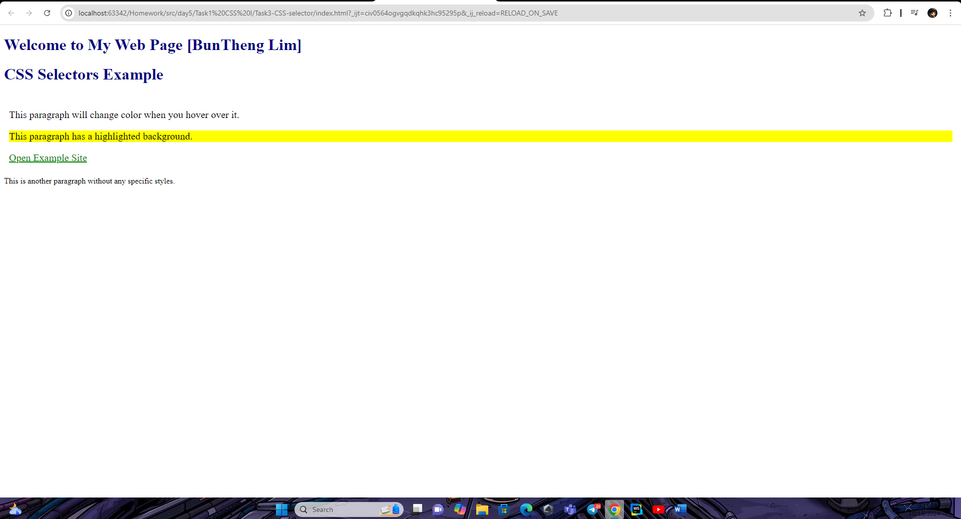

1. Gemini 

Result isn’t the same and chat GPT is better because it’s follow the Prompt